2022 Environmental Risk Management Disclosure Report
LAND BANK OF TAIWAN, SINGAPORE BRANCH

Content
Section 1 Introduction 2
Section 2 Governance and Strategy 3
Section 3 Risk Management 4
3.1 Environmental Risk Management Framework 4
3.2 Environmental Risk Management Process 5
3.3 Conducting Scenario Analysis and Stress Testing 7
3.4 Development and Training 8
Section 4 Metrics and Targets 9
4.1 Review of Existing High Environmental Risk Cases 9
4.2 Results of Climate Scenario Analysis and Stress Testing 11
Section 5 Looking Forward 15

Section 1 Introduction
The Land Bank of Taiwan, Singapore Branch (LBOTS) recognizes that climate change is the biggest environmental challenge facing society, businesses and the economy. As a result, businesses, investors and market participants around the world must face several short- and long-term climate-related risks.

LBOTS supports the Guidelines on Environmental Risk Management for Banks (ENRM Guidelines) promulgated by the Monetary Authority of Singapore (MAS) on environmental risk management for banks, making environmental action and sustainability work the focus of our daily financing.

The disclosure structure of this report refers to the Financial Stability Board's Task Force on Climate-Related Financial Disclosures (TCFD) Pillar Working Group. This inaugural environmental risk disclosure report outlines LBOTS’s overall approach to governance, strategy, risk management, and key metrics and objectives related to environmental-related risks and opportunities.

Section 2 Governance and Strategy
This section outlines the LBOTS Board of Directors (“Board”) and Senior Management’s governance framework and responsibilities in environmental risk management. The Board and Senior Management shall play critical roles in environmental risk management. The Board and Senior Management shall assess the impact of related risks and opportunities on the Bank's overall risk appetite and operational strategy to the objectives set out under international agreements such as the Paris Agreement and national policies, such as the ENRM Guidelines.

The Board is ultimately responsible for the bank in environmental risk management. The Board has appointed a General Manager who primarily resides in Singapore, to be responsible for overseeing the local operations to ensure the sound business operation and proper conduct in the Singapore environment. The General Manager operates under the delegation provided by the Board and mandates the responsibilities for the Bank Environmental Risk Management.

The Senior Management of LBOTS shall develop and implement the environmental risk management framework and policies. The Senior Management of LBOTS shall continuously assess the Bank's environmental exposure, ensuring that the Bank's risk appetite framework covers material environmental risks. The Senior Management of LBOTS is also responsible for periodically reviewing the effectiveness of the framework, policies, tools, and indicators and making appropriate revisions, taking into account changes in the Bank's risk profile and business strategy. If there is a material environmental risk issue, it shall be notified to the Head Office (H. O.) in a timely manner. In 2022, the Senior Management proposed the environmental risk management policy of LBOTS, clearly defined relevant responsibilities and established a sound environmental risk management system.

LBOTS regularly reviews our governance structure with regard to environmental risk management to accelerate and promote the development of finance growth opportunities as we transition to a low-carbon economy.

Section 3 Risk Management
This section provides an overview of LBOTS’s environmental risk management framework and process.

3.1 Environmental Risk Management Framework
Consistent with LBOTS’s overall risk management framework, we have embedded the Three Lines of Defence Model for environmental risk management (refer to Figure 1):
- First Line of Defence – Identifying, measuring, and evaluating the material environmental risks of the case at the first stage; setting up and performing qualitative or quantitative environment-related scenario analysis and stress testing; and, ensuring and monitoring the environmental risk management after the loan is disbursed by Loan Department
• Second Line of Defence – Systematically reviewing and monitoring the execution of environmental risk management by the Loans Committee; formulating the evaluation content and procedures for legal compliance and supervising each unit to regularly conduct self-assessment of compliance and comprehensive legal compliance affairs by the Compliance Department
• Third Line of Defence – Independently checking and evaluating the effectiveness of the environmental risk management internal control and risk management rules designed and implemented by the first and second lines of defence, and providing suggestions for improvement in a timely by Group Internal Audit

Figure 1: Three Lines of Defence Model

3.2 Environmental Risk Management Process

Figure 2: Environmental Risk Management Process

Since 2022, LBOTS has established a comprehensive environmental risk assessment process and proposed the policy to ensure the integrity and rationality of environmental risk management, and to incorporate environmental risk management into the overall risk management framework. To manage environmental risks, we adopt the 4 essential steps of the Risk Management Process, including identifying environmental risks, assessing environmental risks, managing environmental risks, and monitoring on environmental risks (refer to Figure 2). At present, the services provided by LBOTS are mainly credit loans. Therefore, the discussion of environmental risk assessment in this report focuses on that of credit loans.

3.2.1 Identifying Environmental Risks: Define Material Environmental Risks in Industries
According to the definition of MAS ERM Guideline Article 2.1, environmental risks can include climate change risk (climate change), biodiversity risk (loss of biodiversity), pollution risk (pollution), and land-use change risk (changes in land use). On this basis, we refer to the Green and Transition Taxonomy proposed by MAS Green Finance Industry Taskforce (GFIT), and clearly define industries that face material environmental risks, including: “Agriculture and Forestry/Land Use,” “Construction/Real Estate,” Transportation and Fuel,” “Energy, including upstream,” “Industrial,” “Information and Communications Technology,” and “Waste/Circular Economy.”

Based on the aforementioned industries, we have completed a list of industry codes corresponding to the Singapore Standard Industrial Classification (SSIC) Codes. We check whether the existing clients are industries with high environmental risks according to the list of industries. When accepting new credit clients in the future, we will first consider their SSIC code to determine whether they are industries with high environmental risks.

3.2.2 Assessing Environmental Risks: Reviewing the Risks; Conducting Stress Testing and Scenario Analysis
In order to conduct a comprehensive environmental review for our clients, we refer to the Environmental Risk Questionnaire issued by GFIT and the recommendation of TCFD and design the Environmental Risk Management Checklist for the defined high environmental risk industries. Periodically we fill in the Environmental Risk Management Checklist for review and attach it to the annual review report. The checklist is mainly divided into the risk side and the opportunity side.

We assess the risks faced by clients and how to manage them from the perspectives of risk categories and risk management measures. In terms of risk categories, climate risk is considered to be one of the biggest risks in the financial sector affecting loan portfolios and client credit profiles among environmental risks. Therefore, we design the examination questions based on the climate risk framework defined by the Task Force on Climate-related Financial Disclosures (TCFD), which includes physical and transition risks, and takes into account other environmental risks, including biodiversity loss, pollution risk and land-use change risk, etc. In terms of risk management measures, we measure how well our clients implement environmental risk governance, disclosure, risk identification, assessment and mitigation measures.

In addition to the risks, we also include items in the checklist on environmental development opportunities to assess the client's environmental performance. Taking agriculture as an example, we check whether clients have measures to improve the sustainability of agriculture, or whether they have participated in sustainable investment and financing activities, such as low-carbon technology investment, circular economy investment, etc.
In addition, we also conduct climate scenario analysis and stress testing for existing high environmental risk clients, see section 3.3 for details.

3.2.3 Managing Environmental Risks: Client Engagement
For high environmental risk cases (with a high score in the Environmental Risk Management Checklist), we communicate directly with the client or suggest that the syndicated lead bank negotiate and communicate with the client, including but not limited to requiring the client to fill in Engagement Questionnaire, in order to work with the client to respond to the impact of environmental changes and work together towards a sustainable future. The client shall explain its risk mitigation measures in Engagement Questionnaire for the high environmental risk rating indicators in the Environmental Risk Management Checklist.

In the future, when undertaking new credit cases, we will take environmental risks into consideration and gradually reduce the number of cases with high environmental risks.

3.2.4 Monitoring Environmental Risks
The Loans Committee is responsible for monitoring the execution of environmental risk management by the Loan Department. The members of the committee review the environmental risk management review result in the credit assessment report and report the approved cases to the General Manager, H. O. Executive Vice President, H. O. President and the Board according to the scale of the case and the review level within the corresponding authority, and review within their corresponding authority tiers for final approval.

3.3 Conducting Scenario Analysis and Stress Testing
We introduce scenario assumptions to estimate the carbon fees that clients with high environmental risks may bear in the future for scenario analysis. This scenario assumes that carbon price parameters are provided by The Network for Greening the Financial System (NGFS) as a globally applicable indicator of the economic impact of climate change (refer to Figure 3). We choose the following two scenarios to assess the carbon costs that high environmental risk clients may face in 2025, 2050 and 2100:
- Orderly-Net Zero 2050: Countries adopt active climate policies, and the global temperature will be controlled within 1.5°C to achieve zero emissions by 2050.
- Hot House World - Current Policies: Countries have not implemented new policies, greenhouse gas emissions continue to increase, and the global temperature will increase by more than 3°C by the end of the century.

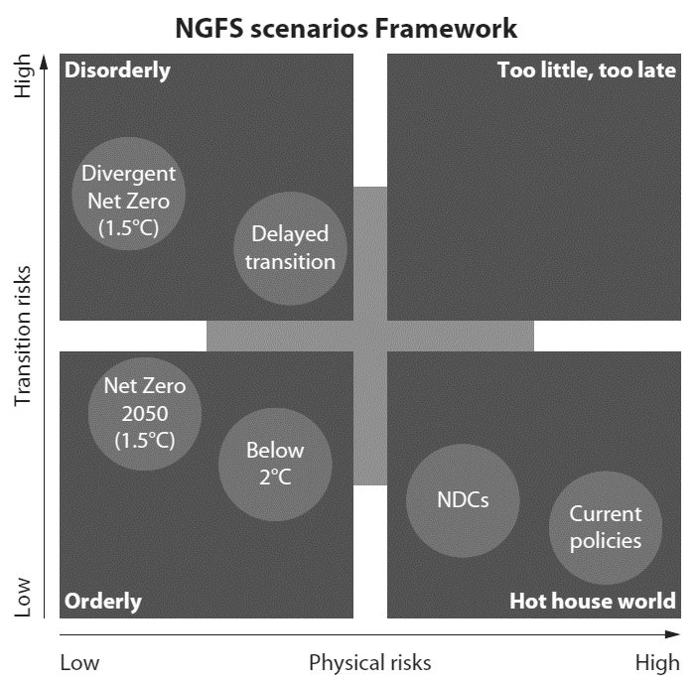
Figure 3: NGFS Scenarios Framework
Because credit clients may be affected by carbon fees imposed by the government in the future, they will bear additional costs to comply with regulatory requirements, and the additional costs will affect their net worth and increase their default rate. Therefore, we conduct the stress testing by factoring the carbon costs in 2025 for both scenarios into the financial statements of credit clients to assess the potential financial impact. We first calculate that the carbon fee levied in the future will be reasonably reflected in the current client's financial performance, and then further calculate the respective default rate and expected credit loss rate (ECL) to assess whether this risk is within the reasonable scope of the bank.

3.4 Development and Training
We regularly provide environmental risk management training for branch personnel and reviewers, so that employees have sufficient environmental risk expertise, and regularly reviews the effectiveness of training. Furthermore, training shall immediately incorporate emerging issues related to environmental risk. In 2022, we hold trainings on environmental risk management for all colleagues.

Section 4 Metrics and Targets
This section presents the results of our review of existing high environmental risk cases, climate scenario analysis and stress testing.

4.1 Review of Existing High Environmental Risk Cases
As of 28 February 2022, we had 8 high environmental risk outstanding credit cases (refer to Figure 4), with an approved credit line of approximately US$134 million, accounting for 28% of the total approved credit line (refer to Figure 5).

Figure 4: The number of high environmental risk and non-high environmental risk credit cases

Figure 5: The amount of high environmental risk and non-high environmental risk credit cases
Referring to the GFIT Taxonomy classification method, as of 28 February 2022, the industry of our existing high environmental risk credit cases is dominated by Industrial (70%), followed by Energy, including upstream (22%) refer to Figure 6. Referring to the SSIC classification method, the industries of our existing high environmental risk credit cases belong to “Manufacture of Petroleum lubricating oil dominated” (37%, $49Million), followed by “Transmission, distribution and sale of electricity” (22%, $30Million) (refer to Figure 7).
Figure 6: High environmental risk credit cases classified by SSIC classification

Figure 7: High environmental risk credit cases classified by GFIT Taxonomy classification

4.2 Results of Climate Scenario Analysis and Stress Testing
Based on the NGFS model, we estimate the carbon fees that may be faced by credit recipients in 2025, 2050, and 2100 for credit cases with high environmental risks. Figure 8 shows that under the Current Policies scenario, credit recipients face higher and higher carbon costs. However, under the Net Zero 2050 scenario, countries may have to adopt faster and more active policies, and the carbon cost in 2050 will be higher than that in 2100.
Figure 8: Total estimated carbon fees for high environmental risk credit cases in 2025, 2050 and 2100 under the Current Policies and the Net Zero 2050 scenario (in millions of US dollars)

Figures 9 and 10 show the estimated carbon fees for different industries under the Current Policies and Net Zero 2050 scenarios, respectively. The results show that the industry of "Industrial" will face the highest potential estimated carbon fee expenditure among our existing credit clients, followed by "Energy, including upstream".

Figure 9: Total estimated carbon cost for high environmental risk credit cases under the Current Policies scenario (in millions of US dollars)

Figure 10: Total estimated carbon cost for high environmental risk credit cases under the Net Zero 2050 scenario (in millions of US dollars)
The results of our stress testing show that in 2025, the expected credit loss rate (ECL) of existing high environmental risk credit clients under the Current Policies scenario and the Net Zero 2050 scenario is approximately 2%. We assess the new ECL under the two scenarios to be within the acceptable range of the bank and will continue to pay attention to the financial impact of carbon price changes in high environmental risk cases.

Section 5 Looking Forward
LBOTS is committed to supporting the transition to a low-carbon economy and recognizes that high-quality disclosure is a key component of this effort. The environmental risk disclosure report will continue to inform LBOTS's strategic priorities of putting clients first, building a sustainable future, acting with integrity, valuing employees and engaging with communities.

We will continue to oversee LBOTS' sustainability management and monitoring at the strategy and decision-making level. This includes assessing environmental risks in the LBOTS loan portfolio and referencing the recommendations made by the ENRM Guidelines.

LBOTS has taken several steps towards the goals we set but is also aware of the challenges that remain. Looking forward, we are committed to driving performance across our key ESG factors, achieving our goals and evolving our practices as needed. We recognize that tackling climate change requires collective action and are committed to partnering and collaborating with others to drive systemic change.

The success of LBOTS is not only intertwined with the success of all our stakeholders - but it is also inextricably linked to the health of the planet. We are committed to prioritizing climate change to ensure LBOTS remain relevant, build resilience and create sustainable long-term value.

"Information and Communications Technology," and "Waste/Circular Economy" are not high-risk industries, but MAS assesses that they play an important role in climate change mitigation or adaptation, and are still included in the high-risk industries of GFIT Taxonomy.
Source: NGFS Climate Scenarios for central banks and supervisors (June 2021)

